Glagoli
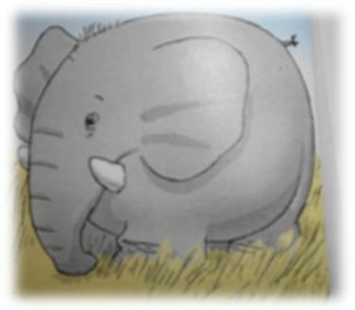
Čudna bolest
Zaboljela slona surla
Pa zbog toga strašno urla.
Stigao i doktor lav.
− Slon je, kaže, posve zdrav.
Od bolova on se znoji
Jer na svojoj surli stoji.
Jadranka Čunčić-Bandov
1. Razmisli i napiši.
a) Što je smiješno u pjesmi?_____________________________________________________
b) Što radi slon? _____________________________________________________________
c) Što se s njim događa? _______________________________________________________
2. Poveži imenice s glagolima. Smisli i napiši rečenice.
patka | rže | _____________________________________________
guska | pače | _____________________________________________
konj | cijuče | ____________________________________________
mačka | mijauče | _____________________________________________
miš gače _____________________________________________
3. Crvenom bojom podcrtaj sve glagole u pjesmi. Smisli priču u kojoj ćeš upotrijebiti te glagole. Napiši naslov.
_____________________________
__________________________________________________________________________
__________________________________________________________________________
__________________________________________________________________________
__________________________________________________________________________
__________________________________________________________________________
__________________________________________________________________________
__________________________________________________________________________
__________________________________________________________________________
__________________________________________________________________________
__________________________________________________________________________
__________________________________________________________________________
__________________________________________________________________________
__________________________________________________________________________
__________________________________________________________________________
__________________________________________________________________________
__________________________________________________________________________
__________________________________________________________________________

