***Od slova do snova***, čitanka za 2. razred

Nastavna jedinica**: *Da pukneš od smijeha***, str. 28.

1. U osmosmjerci pronađi “šaljive“ riječi: HUMOR, ŠALA, SMIJEH, VIC, SMIJEŠAK, SMAJLIĆ, NASMIJAN, DUHOVIT, SMIJEŠAN.

ŠALJIVA OSMOSMJERKA

|  |  |  |  |  |  |  |  |  |  |
| --- | --- | --- | --- | --- | --- | --- | --- | --- | --- |
| K | D | U | H | O | V | I | T | U | L |
| S | M | I | J | E | H | I | D | T | F |
| G | T | Y | M | C | M | N | C | E | L |
| N | A | S | M | I | J | A | N | V | Q |
| G | L | B | Z | X | H | U | M | O | R |
| Q | A | M | G | G | E | P | I | A | W |
| J | Š | S | M | I | J | E | Š | A | K |
| S | M | A | J | L | I | Ć | N | U | Q |
| S | M | I | J | E | Š | A | N | U | C |
| D | W | M | J | O | F | F | P | U | D |
|  |  |  |  |  |  |  |  |  |  |

2. Sjetite se šaljivog događaja u razredu i ispričajte ga ukućanima.

3. Na što moraš paziti kad se šališ?

4. Jesi li se kada ljutila/ljutio zbog ispričane šale? Zašto?

______________________________________________________________________________________________________________________________________________________

5. Kada šala može biti neukusna?

______________________________________________________________________________________________________________________________________________________

6. Pronađi pravu riječ.

Film koji nas nasmijava je ______________________. - ŠALJIVA

Osoba koja nas nasmijava je ___________________. - HUMORISTIČAN

Priča koja nas je nasmijala je ___________________. - DUHOVITA

7. Objasni što je KOMEDIJA.

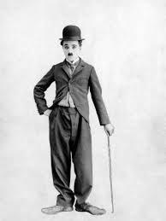8. Znaš li tko je ovo? Pogledaj neki njegov film.

______________________________________________________________________________________________________________________________________________________

9. Kako nazivamo ovakvu vrstu „smiješnog“ crteža?

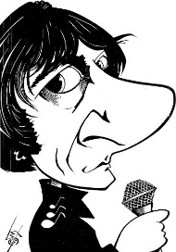

____________________________________________

10. Kako nazivamo cirkuske smiješne zabavljače? ___________________________________