*Od slova do snova*, čitanka za 2. razred

Nastavna jedinica: ***Dušni dan*,** Ivan Boždar, str. 48.

1. Kako si se osjećala/osjećao čitajući ovu pjesmu?

______________________________________________________________________________

2. Kako treba čitati ovu pjesmu?

______________________________________________________________________________

3. Kojim bi bojama naslikala/naslikao pjesničke slike iz prve kitice?

______________________________________________________________________________

4. Koje bi boje koristila/koristio za slikanje sadržaja druge kitice?

______________________________________________________________________________

5. Što je Dušni dan? Znaš li još neki naziv za taj dan?

_____________________________________________________________________________

_____________________________________________________________________________

6. Koje se osobe posebno prisjećaš na Dušni dan?

_____________________________________________________________________________

7. Kako joj odaješ poštovanje i zahvalnost?

_____________________________________________________________________________

8. Napiši ime ovog cvijeta:

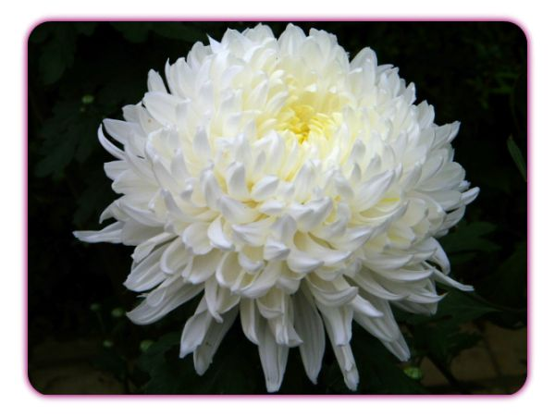

___ ___ ___ ___ ___ ___ ___ ___ ___ ___

Zovu ga cvijet ljubavi i poštovanja.

7. Zašto na groblju palimo svijeće? Što one predstavljaju?

_______________________________________________________________________________

_______________________________________________________________________________

10. Kako se treba ponašati na groblju?

________________________________________________________________________________