OTVORNICI, ZATVORNICI, REČENICA

1. Zaokruži sve otvornike u riječima.

DORUČAK PECIVO AUTOBUS POSAO ZABAVA ČETKA KNJIGA

VRATA STABLO TONI RAČUNALO ZVUK SREDINA PRIČA

2. Dopiši otvornik i prepiši riječ.

tat__ = _________________________ ___blak = _________________________

m___st = _________________________ m___š = _________________________

slov___ = _________________________ z___ko = _________________________

pl___nina = _________________________ k___ma = _________________________

kr___lo = _________________________ r___đak = _________________________

3. Prebroji i napiši koliko ukupno ima otvornika u riječima iz prethodnoga zadatka.

A = ___________ E = ____________ I = ___________ O =____________ U = ____________

Ukupno svih otvornika u zadanim riječima je ___________________________.

4. Spoji dijelove riječi iz lijevoga i desnoga stupca tako da dobiješ imenicu.

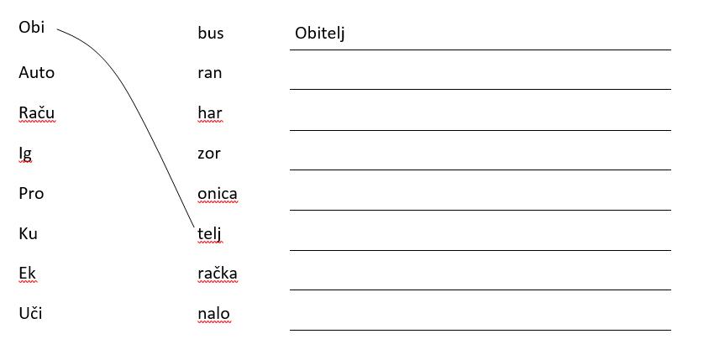

5. Ispravi sve pogreške. Ispravljene rečenice prepiši.

Ja smo Ivan. Idem u drgi razrd osnovni škole. Jučer som učili otvornike. Ima ih pet. To su a, e, i, u. Zovu se još i samoglasnici. Moje ime ima dva samglasnika. Važon je znati glasove.

__________________________________________________________________________

__________________________________________________________________________

__________________________________________________________________________

__________________________________________________________________________

__________________________________________________________________________

__________________________________________________________________________